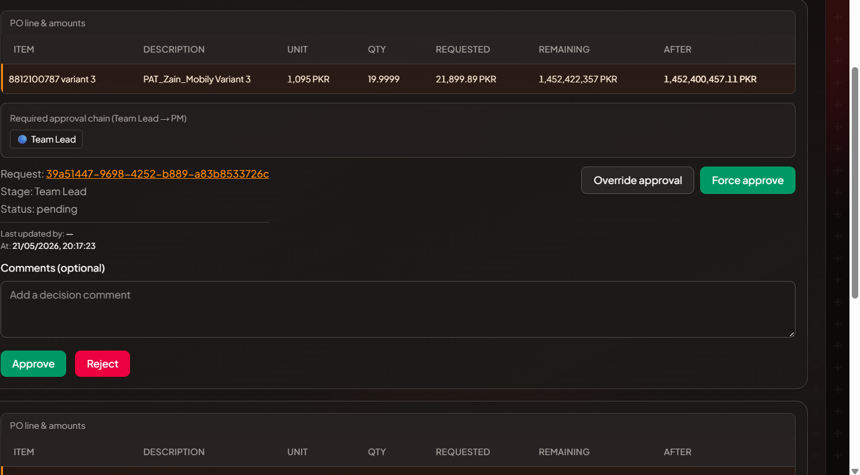
In Super admin login (hammad.bakhtiar) it is not approved
also check approval for Balajnadeemkiani
as well as check overall approval,Force Approve and override approve functionality.

